**2021.11.09 Capacitance Experiment**

**Start Time:** circa 09.00

Aim

An experiment was carried out to measure the capacitance of a large and small capacitor, using an oscilloscope to record data for the decay curve, as well as using data from phase shifts for the small capacitor.

Background

Capacitors are a component used to store electrical energy through a separation of charge between its two plates. In a short-circuited configuration (as shown on the left of Figure 1), both plates of the capacitor are connected by a wire so that the potential of both are identical - the free, negatively-charged electrons are uniformly interspersed among the fixed positively-charged metal ions.

If we are to supply a voltage, V, from a battery (as shown on the right of Figure 1), an excess positive charge builds up on one plate, an excess negative on the other; this separation of charge across the insulator in between generates an electric field opposite to the direction caused by the battery to drive current. This stores energy in the capacitor. Once both are equal, there can be no further flow of electrons in the circuit - the capacitor is fully charged. Then, subsequently removing the battery and short-circuiting it with cause electrons to flow around the circuit again (in the opposite direction), discharging the capacitor. This method of storing electrical energy is utilised in camera flashes.

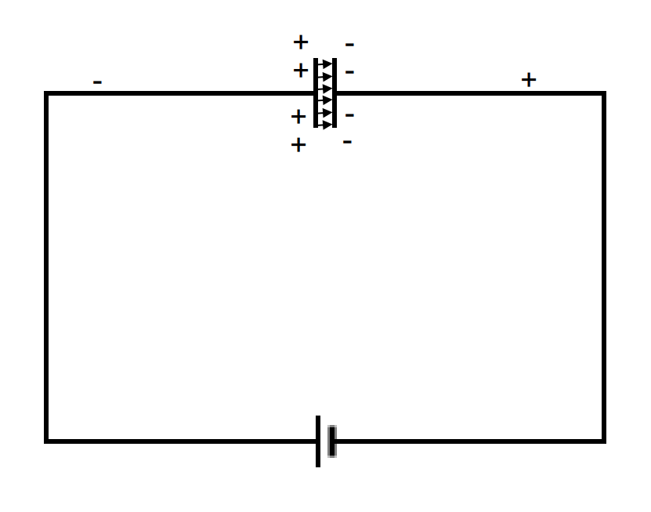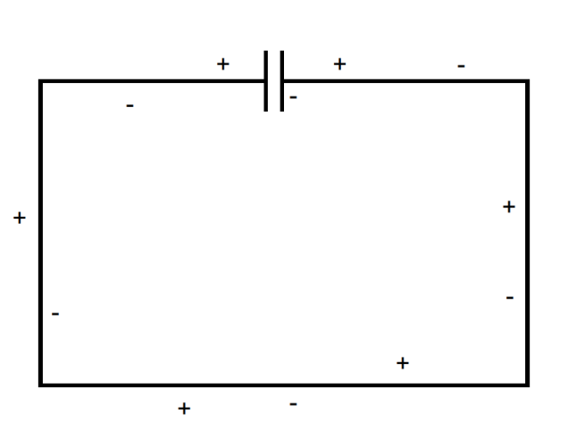

Figure 1: Charge distributions on an uncharged capacitor, as outlined in the short-circuited scenario, and on a charged capacitor when the circuit is closed and a voltage V is supplied by a battery.

The quantity of charge provided by capacitor plates (Q / F) is given by:

$$Q = C · V (1)$$

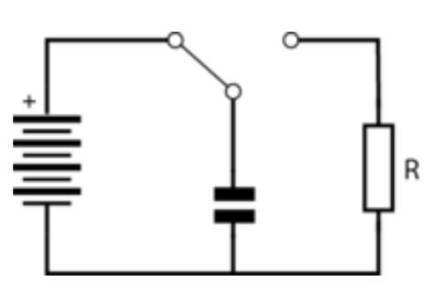A R-C circuit can be set up if a charged capacitor is then connected to a resistor. The current will subsequently flow from one plate through the resistor R; when we combine Ohm’s Law with (1), we arrive the following relation:

$$I=\frac{Q}{R·C} (2)$$

As a result, knowing that current is the differential of charge, we arrive at the differential equation:

$$\frac{dQ}{dt} = −\frac{Q}{R·C} (3)$$

Figure 2: Schematic of R-C circuit through which capacitor can be charged and discharged

which has the solution, if the capacitor had initial charge Q0:

Consequently, there should be an exponential discharge from the capacitor with time constant 1 / RC. From (1), it follows that being able to accurate record voltage against time during the discharge means that we can measure the capacitances.

In order to use phase shifts *(of sine waves)* to measure capacitance, we know that:

$$C_{ total in the circuit} = \frac{1}{2π · v · X_{c}} (5)$$

whereby *v* gives the driving frequency of the signal generator, XC gives the total reactance of capacitors in the circuit. In AC circuits, reactance behaves similarly to resistance and opposes changes in current which can lead to attenuation, resulting in phase differences between input and output signals that have already been given. The reactance is given by:

$${ X}_{c}=\frac{V_{x}}{I_{g}·cos(φ)} (6)$$

whereby Ig is the current supplied by the signal generator, given by $I_{g}=\frac{V_{R1}}{R_{1}}$, φ is the “Loss Angle” and Vx is the voltage amplitude across the capacitor. The loss angle (φ) is given by:

$$φ=arccos(\frac{V_{g}·sin(α)}{V_{R1}}) (7)$$

whereby Vg is the voltage amplitude of the signal generator signal, α is the phase difference between signal generator and capacitor signal, and VR1 gives the voltage drop across resistor R1, given in Figure 1.4 *(see Description of Set Up)*. Knowing that current supplied by the signal generator, Ig, is given by $I_{g}=\frac{V_{R1}}{R_{1}}$, where R1 gives the resistance of resistor R1, we have that VR1 is given by:

$${ V}_{R1}=\sqrt{(V_{g} · cos(α)−V_{x})²+(V_{g} · sin(α))²} (8)$$

Description of Set Up / Measurement Strategy

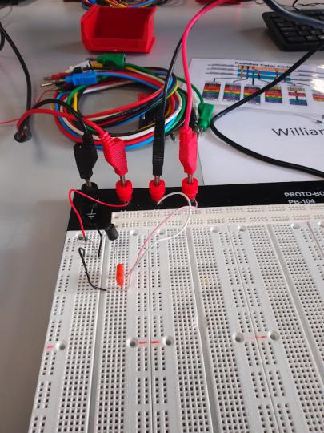

The practical consisted of three experiments: measuring capacitance of a large capacitor using discharge decay; measuring capacitance of a small capacitor using discharge decay; measuring the capacitance of a small capacitor using phase shift.

In the first of these experiments, the capacitance of an electrolytic capacitor was determined through setting up an R-C circuit as shown in Figure 2.

An electronic breadboard was used to construct this circuit, and a resistor, of R ≈ 10kΩ was used, as well as the 1mF capacitor provided. A piece of wire was used as a three-way switch in order to alternate between charging and discharging the capacitor. Then, an oscilloscope was set up to measure the voltage across the capacitor, and a USB stick was plugged in in order to save the data from the oscilloscope trace. Having adjusted the x and y-axes so that a full discharge curve would fit the display, the capacitor was discharged through resistor, R.

In the second of these experiments, the above method was replicated, however using a small ceramic capacitor with a resistor, of R ≈ 100kΩ. Instead of a three-way switch, the capacitor and resistor were connected in series with the signal generator built into the oscilloscope. By selecting a square wave which oscillates between 0 and 2V, the capacitor will charge when the signal is high, and discharge through resistor R when the voltage, V = 0V. The signal generator of the oscilloscope produces a 2V peak-to-peak square wave, and it is offset by 1V, so that the waveform starts at 0V, rising to +2V. The frequency f, is set to ≈5kHz. As a result, the voltage should be observed to be rising during the charging phase, and falling during the discharging.

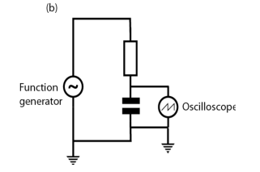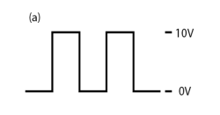

Figure 3: (b - Left) Measuring voltage across the capacitor, using the signal generator built in to the oscilloscope to charge and discharge the capacitor. (a - Right) Pulse shape for charging/discharging.

Source: Mangles et. al, 2021, “Year 1 Laboratory Manual: Capacitance Experiment”, Imperial College

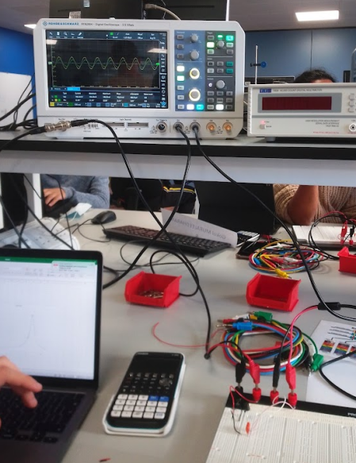In the final one of these experiments, a capacitor of extremely low capacitance was used, and so a different method must be utilised when we use a 6.8kΩ resistor and a 20pC capacitor, as the capacitance of the oscilloscope is comparable to that of the capacitor itself. The signal generator is set up to drive the circuit with a 50kHz sine wave with a 2V peak-to-peak, ensuring that the x and y-scale are adjusted accordingly, and the signal generated by the scope as well as the voltage across the capacitor can be seen on the oscilloscope trace. The amplitude of the capacitor signal as compared to the signal generator should be lower, and phase shifted. Measurements of VX, Vg and α were then subsequently obtained from data that was taken, and recorded onto a .CSV file on a USB stick for analysis.

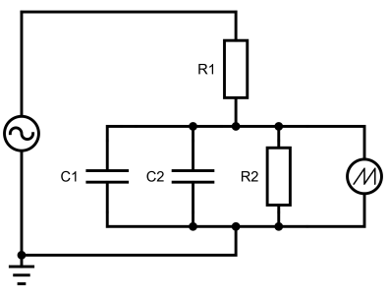

Figure 4: Circuit diagram to measure voltage across capacitor, whilst taking into account the capacitance of the oscilloscope. C2 and R2 represent capacitance and resistance introduced by the oscilloscope.

Source: Mangles et. al, 2021, “Year 1 Laboratory Manual: Diffraction Experiment”, Imperial College

Data Analysis

Due to an abundance of data, please find the below .CSV files outlining our recorded data:

<<E3T1C01.csv>>

<<E3T1C02.csv>>

<<E3T1C03.csv>>

<<2021.11.11 Capacitance.xlsx>>

Data was recorded synchronously on Excel.

The following phase shift data was obtained from the oscilloscope:

**Experiment 1: Measuring the capacitance of a large capacitor using discharge decay**

Rearranging (4), we have that:

$$ln(V) = ln(V_{0})−\frac{1}{RC}· t (9)$$

Rearranging the expression: $gradient = −\frac{1}{R · C}$ for the capacitance, we know that:

$$C = −\frac{1}{R × gradient} (10)$$

Consequently, the capacitance can be calculated from the gradient of the linear plots.

The following plots were generated using Python, and done in VSCode:

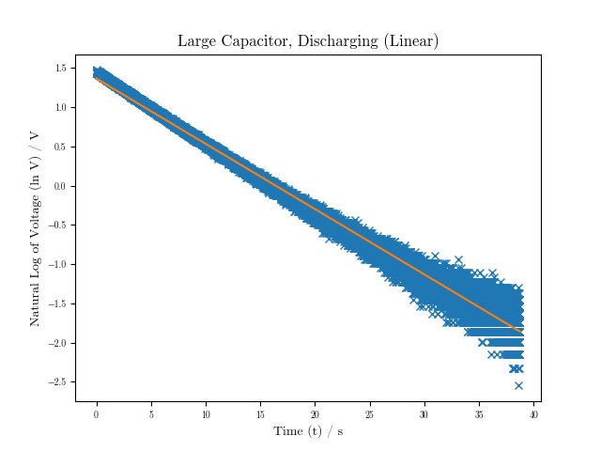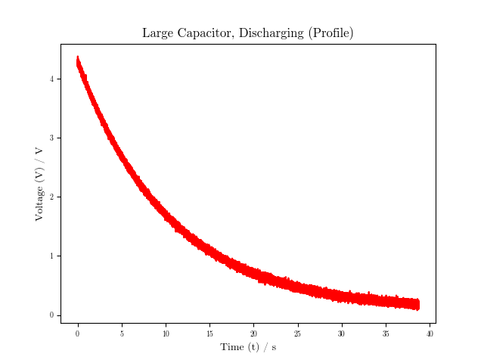

 OUTPUT

polyfitLCD

[-0.08326937  1.36631875]

cov_polyfitLCD

[[ 7.69349878e-10 -1.48946052e-08]

[-1.48946052e-08  3.84475744e-07]]

**Experiment 2: Measuring the capacitance of a small capacitor using discharge decay**

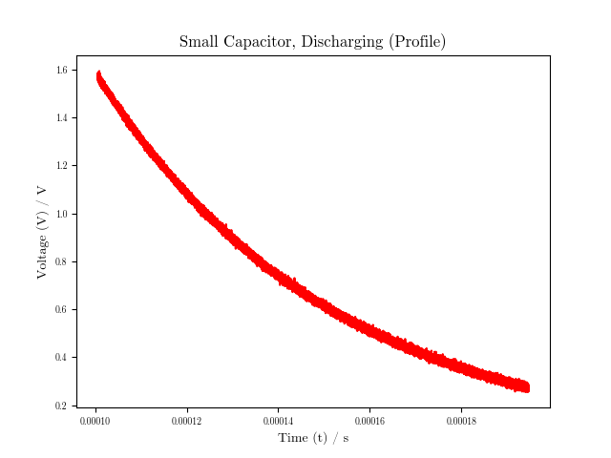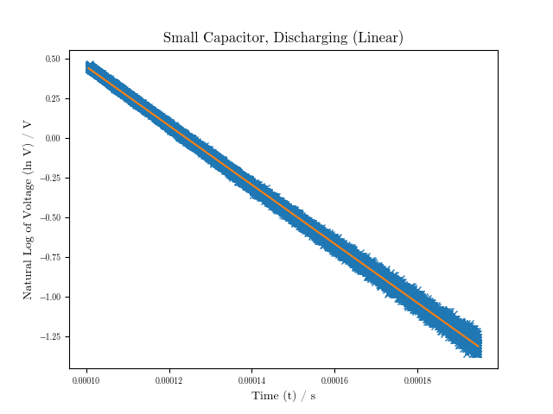

OUTPUT

polyfitSCD

[-1.86250220e+04  2.31339893e+00]

cov_polyfitSCD

[[ 6.10821426e+00 -9.01758115e-04]

[-9.01758115e-04  1.37636544e-07]]

**Experiment 3: Measuring the capacitance of a small capacitor using phase shift**

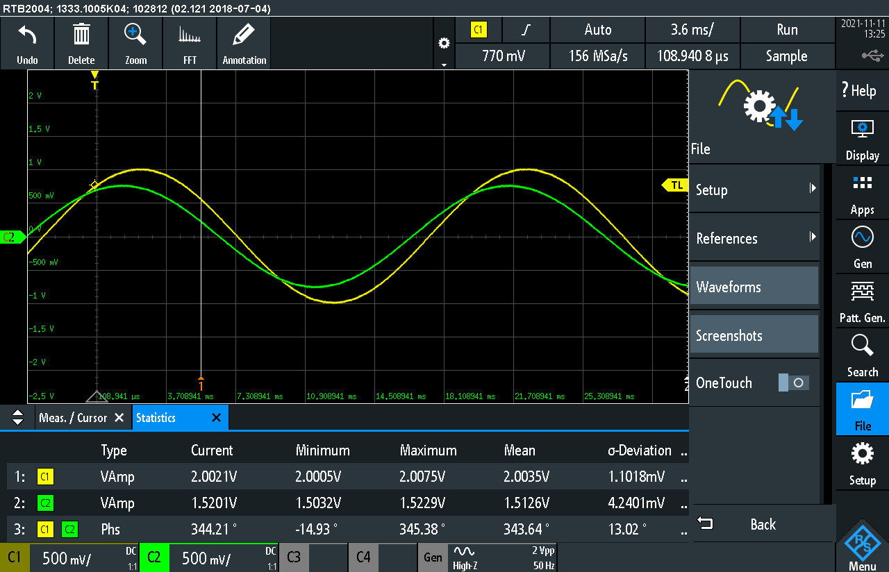

**Redacted Python Code** to plot profiles, and obtain subsequent linear plot

timeLCD,voltageLCD = np.loadtxt(*r*"2021.11.11 Capacitance - Computing/E3T1C01.csv",*delimiter*=",",*skiprows*=42477,*unpack*=True) # LCD - Large Capacitor, using Discharge

timeSCD,voltageSCD = np.loadtxt(*r*"2021.11.11 Capacitance - Computing/Capacitance2.csv",*delimiter*=",",*skiprows*=2894,*unpack*=True) # SCD - Small Capacitor, using Discharge

*def* discharge(*t*,*V0*,*R*,*C*):

return *V0*\*exp(-*t*/(*R*\**C*))

*def* dischargeLinear(*t*,*V0*,*R*,*C*):

return log(*V0*)-*t*/(*R*\**C*)

*def* capacitance(*R*,*gradient*):

return -1/(*R*\**gradient*)

plt.plot(timeLCD, voltageLCD,'r')

plt.plot(timeLCD, log(voltageLCD), 'x') # Plot the points onto the linear plot

polyfitLCD,cov_polyfitLCD = np.polyfit(timeLCD, log(voltageLCD), 1, *cov*=True)

plt.plot(timeLCD, (polyfitLCD[0]*timeLCD+polyfitLCD[1]))

plt.plot(timeSCD, voltageSCD,'r')

polyfitSCD,cov_polyfitSCD = np.polyfit(timeSCD, log(voltageSCD), 1, *cov*=True)

plt.plot(timeSCD, (polyfitSCD[0]*timeSCD+polyfitSCD[1]))

gradientSCD = ufloat(polyfitSCD[0],cov_polyfitSCD[0,0])

gradientLCD = ufloat(polyfitLCD[0],cov_polyfitLCD[0,0])

capacitanceSCD = capacitance(R_SCD,gradientSCD)

capacitanceLCD = capacitance(R_LCD,gradientLCD)

**Sources of Uncertainty (Raw Data)**

|  |
| --- |
| **Covariance Matrix for Linear Regression Fit on Discharge Decay Data** |
| The square root of the covariance matrices were used in order to calculate the uncertainties in the capacitor orignating from the polyfit function covariance matrix.  **Uncertainties in Third Experiment - Measuring Small Capacitor’s Capacitance using Phase Shift** |
| Values are defined as (value, standard deviation of value)  Vgpeak = ufloat(2.0035,1.1018E-3)  Vxpeak = ufloat(1.4126,4.2401E-3)  Vg,Vx = Vgpeak/2,Vxpeak/2  α = ufloat((360-343.64)*π/180,13.02*π/180)  R1 = ufloat(6.8E3,0) # σ of resistance R1 unknown, so omitted from calculations  v = ufloat(50E3,0) # σ in driving frequency on oscilloscope unknown  C2 = ufloat(20E-12,0) # Uncertainty in model for capacitance of oscilloscope unknown  R2 = ufloat(1E6,0)  Using the Python uncertainties package, errors were automatically propagated following on from the data.  import uncertainties as unc  from uncertainties import umath  from uncertainties import ufloat  Consequently, omitting all the need for quadratures and the like, the following data was obtained after using the built in *umath* and *ufloat* functions to propagate all the errors from the polyfit functions:  C1 = 1.6700555766030673e-10+/-1.447614674349116e-10 F  where C1 represents the small ceramic capacitor used in Experiments 2 and 3.  Uncertainties in values which were unknown were omitted from the error propgation calculations, and σ defined as 0. In Experiments 1 and 2, they are as follows:  R_LCD = ufloat(10E3,0) # σ in resistance of resistor used (LCD experiment) unknown  R_SCD = ufloat(100E3,0) # σ in resistance of resistor used (SCD experiment) unknown  In Experiment 3, they are as follows:  R1 = ufloat(6.8E3,0) # σ of resistance R1 unknown, so omitted from calculations  v = ufloat(50E3,0) # σ in driving frequency on oscilloscope unknown  C2 = ufloat(20E-12,0) # Uncertainty in model for capacitance of oscilloscope unknown  R2 = ufloat(1E6,0) |

Results / Summary

Applying (10) to the values we obtain from polyfitLCD and polyfitSCD, which gave the corresponding covariance matrices to the least-square regressions that were obtained, and using the uncertainties library in Python for all three experiments, we calculate:

The capacitance of the large capacitor in the first experiment: (1.2×10¯³ ± 3×10¯⁵) F

The capacitance of the small capacitor in the second experiment: (5.4×10¯¹⁰ ± 1.8 ×10¯¹³) F

The capacitance of the small capacitor in the third experiment: (1.67×10¯¹⁰ ± 1.44 ×10¯¹⁰) F

We were given in the lab manual that the large capacitor was approximately 1mF, which corroborates our calculated value of ≈ 1.200 mF. The uncertainty range, as obtained from the least-squares regression, was very small, likely due to the large number of data points (hence when n is large, σ decreases massively, and uncertainty in the resistance of the resistor used was unknown). Clearly, uncertainties exist in other forms during this experiment, particularly with components of such low capacitance, but since they were unknown, were omitted from error propagation.

In the following experiments, a ceramic capacitor was utilised and it was found on the Internet that ceramic capacitors have very low capacitance, typically in the range of 1 nF - 1μF. However, by decoding the code on the capacitors “471”, we found the capacitor to have roughly a capacitance of 470pF. This is outside both uncertainty ranges calculated in the second and third experiments, but in the same order of magnitude as both of 10¯¹⁰, and somewhere in between both of them. While neither of the obtained values were accurate as compared to the actual value of the capacitor we used, the phase shift method allows for error to be propagated in a far more quantitative and precise manner, taking into account even the oscilloscope’s internal resistance and capacitance. Therefore, whilst our data at first glance suggests that the latter method’s precision is inferior to the former, this is very likely not to be the case.